**: How to Create a Public Linux Instance on AWS :**

Step 1: Login to AWS



Step 2: After login to AWS Console you will get Welcome Dashboard. Then click on EC2

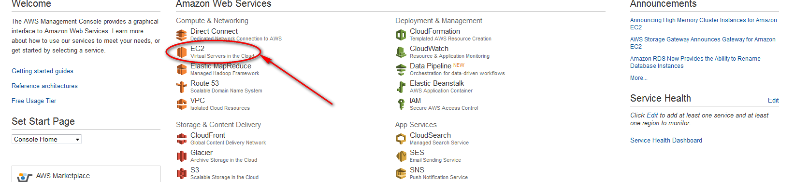

Step 3: Click on Lunch Instance

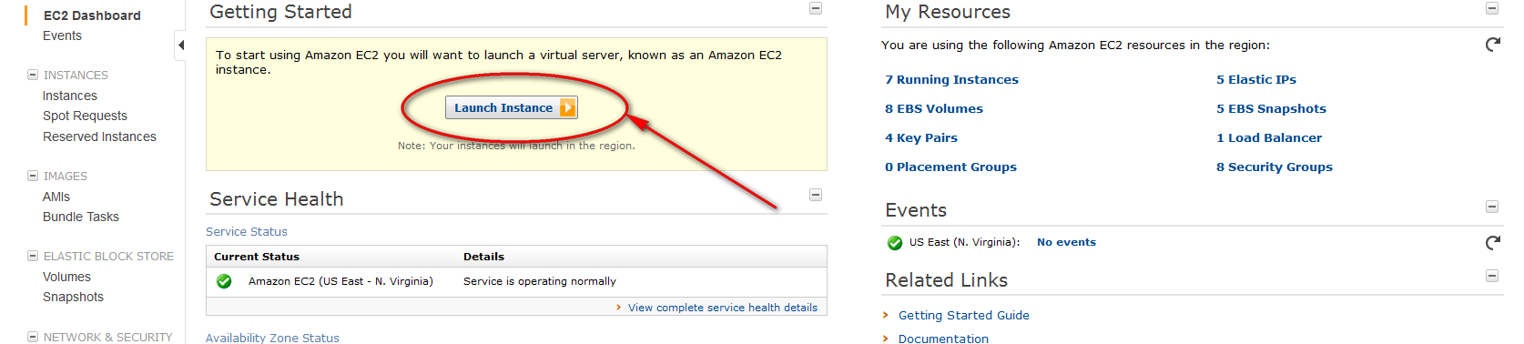

Step 4: Create New key pair and download the key to use it for ssh to the instance.

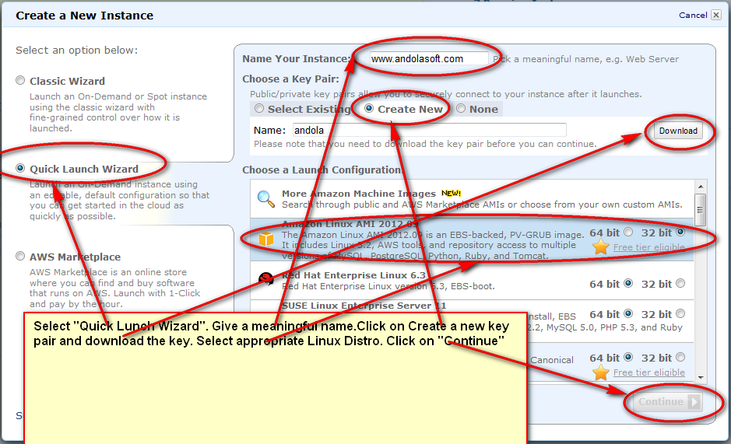

Step 5: Click on “Edit details”

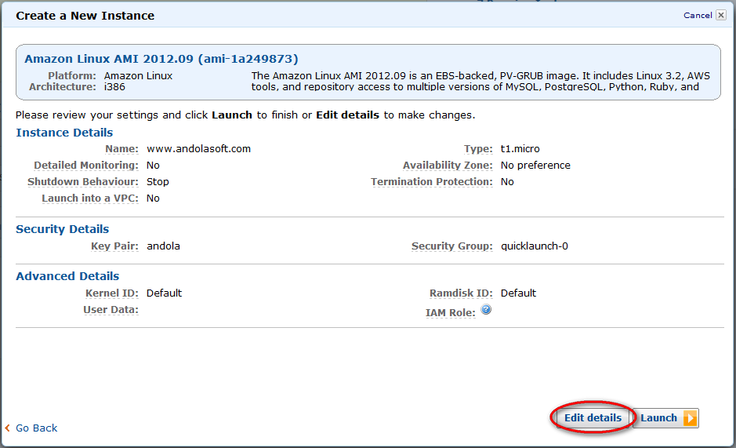

Step 6: Chose Instance type, availability zone and then click on “Security Settings.”

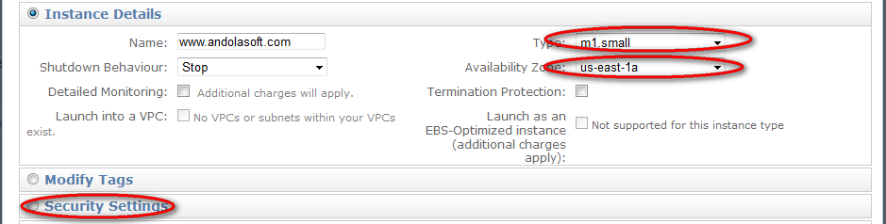

Step 7: Configure Security settings.

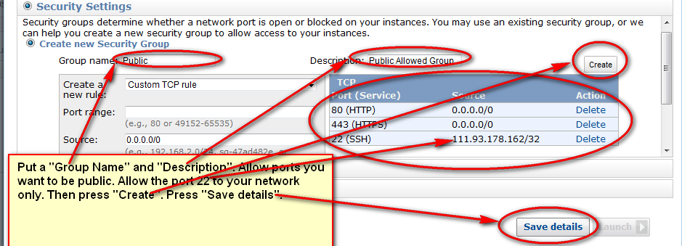

Step 8 : Now Click on Lunch



Step 9: Verify your instance status here.

